EXERCISE 3.1

**NCERT Solutions for Class 10 Chapter 3-**

**Pair of Linear Equations in Two Variables**

EXAMBUDDY

Question 1:

Form the pair of linear equations in the following problems, and find their solutions graphically.

1. 10 students of Class X took part in a Mathematics quiz. If the number of girls is 4 more than the number of boys, find the number of boys and girls who took part in the quiz.

**Solution:**

(i)Let there are x number of girls and y number of boys. As per the given question, the algebraic expression can be represented as follows.

X+Y = 10

X-Y =4

Now, for x+y = 10 or x = 10−y, the solutions are;

For x – y = 4 or x = 4 + y, the solutions are;

The graphical representation is as follows;

**From the graph, it can be seen that the given lines cross each other at point (7, 3). Therefore, there are 7 girls and 3 boys in the class.**

1. 5 pencils and 7 pens together cost 50, whereas 7 pencils and 5 pens together cost 46. Find the cost of one pencil and that of one pen.

**Solution:**

**(ii)** Let 1 pencil costs Rs.x and 1 pen costs Rs.y.

According to the question, the algebraic expression cab be represented as;

5x + 7y = 50

7x + 5y = 46

For 7x + 5y = 46 or x = (46-5y)/7, the solutions are;

Hence, the graphical representation is as follows;

From the graph, it is can be seen that the given lines cross each other at point (3, 5).

So, the cost of a pencil is 3/- and cost of a pen is 5/-.

Question 2:

On comparing the ratios a1/a2 , b1/b2 , c1/c2 find out whether the lines representing the following pairs of linear equations intersect at a point, are parallel or coincident:

1. **5x – 4y + 8 = 0**

**7x + 6y – 9 = 0**

1. **9x + 3y + 12 = 0**

**18x + 6y + 24 = 0**

1. **6x – 3y + 10 = 0**

**2x – y + 9 = 0**

**Solution**

(i) 5x - 4y + 8 = 0 and 7x + 6  - 9 = 0

a₁ = 5, b₁ = - 4, c₁ = 8

a₂ = 7, b₂ = 6, c₂ = - 9

a₁/a₂ = 5/7...(1)

b₁/b₂ = -4/6 = -2/3...(2)

From (1) and (2)

a₁/a₂ ≠ b₁/b₂

Therefore, they are intersecting lines at a point.

(ii) 9x + 3y + 12 = 0 and 18x + 6y + 24 = 0

a₁ = 9, b₁ = 3, c₁ = 12

a₂ = 18, b₂ = 6, c₂ = 24

a₁/a₂ = 9/18 = 1/2...(1)

b₁/b₂ = 3/6 = 1/2...(2)

c₁/c₂ = 12/24 = 1/2...(3)

From (1), (2) and (3)

a₁/a₂ = b₁/b₂ = c₁/c₂= 1/2

Therefore, they are coincident lines.

(iii) 6x – 3y + 10 = 0 and 2x – y + 9 = 0

a₁ = 6, b₁ = - 3, c₁ = 10

a₂ = 2, b₂ = - 1, c₂ = 9

a₁/a₂= 6/2 = 3...(1)

b₁/b₂= - 3/(- 1 ) = 3...(2)

c₁/c₂= 10/9...(3)

From (1), (2) and (3)

a₁/a₂ = b₁/b₂ ≠ c₁/c₂ Therefore, they are parallel lines.

Question 3:

On comparing the ratios a₁/a₂, b₁/b₂ and c₁/c₂, find out whether the following pair of linear equations are consistent, or inconsistent.  
(i) 3x + 2 y = 5; 2x - 3y = 7

3x + 2y = 5; 2x - 3y = 7

a₁/a₂= 3/2

b₁/b₂ = 2/(-3)

c₁/c₂ = - 5/(-7) = 5/7

From the above,

a₁/a₂ ≠ b₁/b₂

Therefore, lines are intersecting and have a unique solution,

Hence, the pair of equations is consistent.

(ii) 2x - 3y = 8; 4x - 6y = 9

2x - 3y = 8; 4x - 6y = 9

a₁/a₂ = 2/4 = 1/2

b₁/b₂ = -3/(-6) = 1/2

c₁/c₂= -8/(-9) = 8/9

From the above,

a₁/a₂ = b₁/b₂ ≠ c₁/c₂

Therefore, these lines are [parallel](https://www.cuemath.com/geometry/parallel-lines/)and have no solution,

Hence, the pair of equations is inconsistent.

(iii) 3/2x + 5/3y = 7; 9x -10y = 14

3/2x + 5/3y = 7; 9x -10y = 14

a₁/a₂ = (3/2)/9 = (3/2) × (1/9) = 1/6

b₁/b₂ = (5/3)/(-10) = (5/3) × 1/(-10) = 1/(-6) = -1/6

From the above,

a₁/a₂ ≠ b₁/b₂

Therefore, lines are intersecting and have a unique solution.

Hence, they are consistent.

(iv) 5x - 3y = 11; -10x + 6y = -22

5x - 3y = 11; -10x + 6y = -22

a₁/a₂ = 5/(-10) = -1/2

b₁/b₂ = -3/6 = -1/2

c₁/c₂ = -11/22 = -1/2

From the above,

a₁/a₂ = b₁/b₂ = c₁/c₂

Therefore, lines are coincident and have infinitely many solutions.

Hence, they are consistent.

(v) 4/3x + 2y = 8; 2x + 3y = 12

4/3x + 2y = 8; 2x + 3y = 12

a₁/a₂= (4/3)/2 = (4/3) × (1/2) = 2/3

b₁/b₂= 2/3

c₁/c₂= -8/(-12) = 2/3

From the above,

a₁/a₂ = b₁/b₂ = c₁/c₂

Therefore, lines are coincident and have infinitely many solutions.

Hence, they are consistent.

Question 4:

Which of the following pairs of linear equations are consistent/inconsistent? If consistent, obtain the solution graphically:  
(i) x + y = 5, 2x + 2y = 10  
(ii) x - y = 8, 3x - 3y =16  
(iii) 2x + y - 6 = 0, 4x - 2y - 4 = 0  
(iv) 2x - 2y - 2 = 0, 4x - 4y - 5 = 0

SOLUTIONS

(i)

x + y = 5, 2x + 2y = 10

a₁/a₂= 1/2

b₁/b₂= 1/2

c₁/c₂= -5/(-10) = 1/2

From the above,

a₁/a₂ = b₁/b₂ = c₁/c₂

Therefore, lines are coincident and have infinitely many solutions. Hence, they are consistent.

x + y - 5 = 0

y = - x + 5

y = 5 – x

|  |  |  |
| --- | --- | --- |
| *x* | 1 | 2 |
| y = 5- x | 4 | 3 |

2x + 2y - 10 = 0

2y = 10 - 2x

y = 5 – x

|  |  |  |
| --- | --- | --- |
| *x* | 3 | 4 |
| y = 5- x | 2 | 1 |

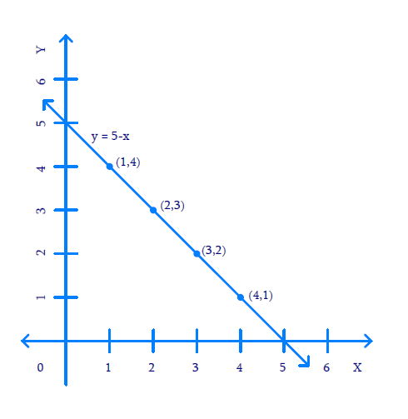

(ii) x - y = 8, 3x - 3y =16

a₁/a₂ = 1/3

b₁/b₂ = -1/(-3) = 1/3

c₁/c₂ = - 8/(-16) = 1/2

From the above,

a₁/a₂ = b₁/b₂ ≠ c₁/c₂

Therefore, lines are parallel and have no solution.

Hence, the pair of equations are inconsistent.

**(iii)**

2x + y - 6 = 0, 4x - 2y - 4 = 0

a₁/a₂ = 2/4 = 1/2

b₁/b₂ = 1/(-2) = -1/2

c₁/c₂ = -6/(-4) = 3/2

From the above,

a₁/a₂ ≠ b₁/b₂

Therefore, lines are intersecting and have a unique solution.

Hence, they are consistent.

2x + y - 6 = 0

y = 6 - 2x

|  |  |  |
| --- | --- | --- |
| *x* | 0 | 2 |
| y = 6 - 2x | 6 | 2 |

4x - 2y - 4 = 0

2y = 4x - 4

y = 2x - 2

|  |  |  |
| --- | --- | --- |
| *x* | 2 | 3 |
| *y*= 2*x*- 2 | 2 | 4 |

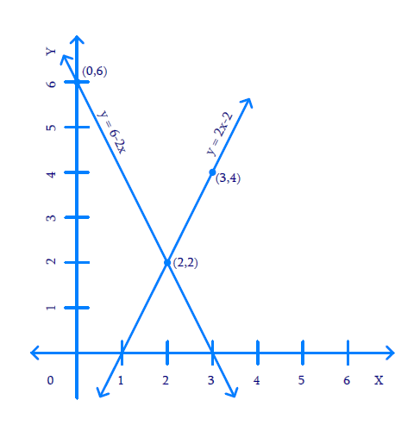

(iv)

2x - 2y - 2 = 0, 4x - 4y - 5 = 0

a₁/a₂ = 2/4 = 1/2

b₁/b₂ = -2/(-4) = 1/2

c₁/c₂ = -2/(-5) = 2/5

From the above,

a₁/a₂ = b₁/b₂ ≠ c₁/c₂

Therefore, lines are parallel and have no solution.

Hence, the pair of equations are inconsistent

Question 5:

Half the perimeter of a rectangular garden, whose length is 4 m more than its width, is 36 m. Find the dimensions of the garden

Solutions:

Assuming the length of the garden as x and the width of the garden as y,

Perimeter of rectangle = 2(length + breadth)

Let the length of the garden be x and breadth be y

Then x = y + 4 [ Since its given that length is 4 m more than its width]

x - y = 4

y = x – 4

|  |  |  |
| --- | --- | --- |
| *x* | 8 | 16 |
| y = x - 4 | 4 | 12 |

The half perimeter of the rectangle is x + y = 36 [Since, perimeter = 2(x + y)]

y = 36 - x

|  |  |  |
| --- | --- | --- |
| *x* | 16 | 26 |
| y = 36 - x | 20 | 10 |

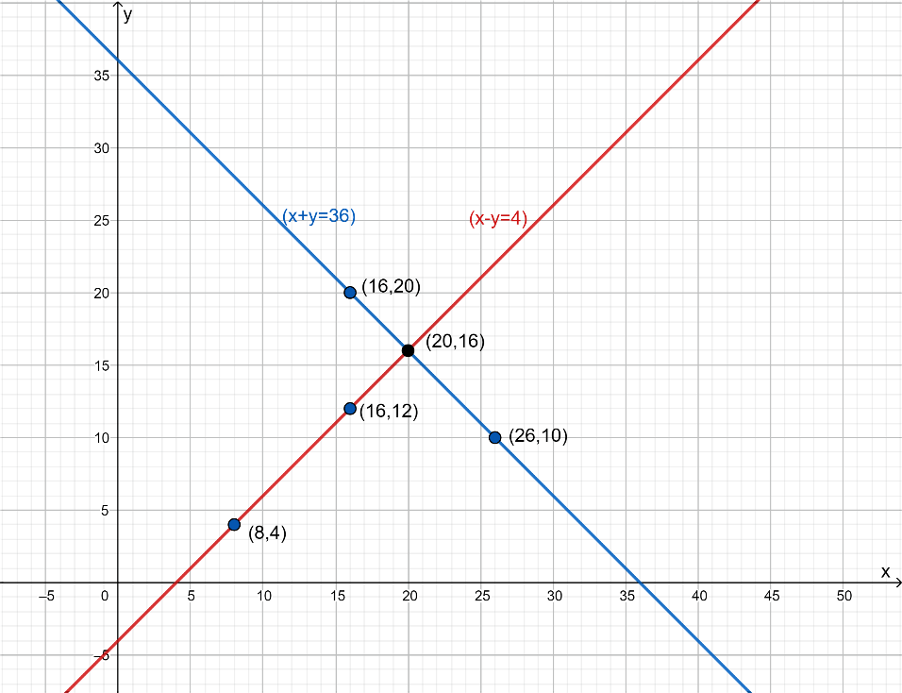

Thus, Length, x = 20 m and Breadth, y = 16 m

Question 6:

Given the linear equation 2x + 3y - 8 = 0, write another linear equation in two variables such that the geometrical representation of the pair so formed is:  
(i) intersecting lines  
(ii) parallel lines  
(iii) coincident lines

**Solution:**

**(i)** **Intersecting lines**

Condition: a₁/a₂ ≠ b₁/b₂

2x + 3y - 8 = 0

a₁ = 2

b₁ = 3

So, considering a₂ = 3 and b₂ = 2 will satisfy the condition for intersecting lines. c₂ can be any value.

a₁/a₂ = 2/3

b₁/b₂ = 3/2

2/3 ≠ 3/2

Therefore, another linear equation is 3x + 2y - 6 = 0

**(ii) Parallel lines**

Condition: a₁/a₂ = b₁/b₂ ≠ c₁/c₂

2x + 3y - 8 = 0

a₁ = 2

b₁ = 3

c₁ = - 8

So, considering a₂ = 4, b₂ = 6, c₂ = 9 will satisfy the condition for [parallel lines](https://www.cuemath.com/geometry/parallel-lines/).

a₁/a₂ = 2/4 = 1/2

b₁/b₂ = 3/6 = 1/2

c₁/c₂ = - 8/9

Thus, a₁/a₂ = b₁/b₂ ≠ c₁/c₂

Therefore, another linear equation is 4x + 6y + 9 = 0

**(iii) Coincident lines**

Condition: a₁/a₂ = b₁/b₂ = c₁/c₂

2x + 3y - 8 = 0

Condition: a₁/a₂ = b₁/b₂ ≠ c₁/c₂

2x + 3y - 8 = 0

We know that, a₁= 2, b₁= 3, c₁= - 8

So, considering a₂ = 4, b₂ = 6, c₂ = - 16 will satisfy the condition for coincident lines.

a₁/a₂ = 2/4 = 1/2

b₁/b₂ = 3/6 = 1/2

c₁/c₂ = - 8/(-16) = 1/2

Thus, a₁/a₂ = b₁/b₂ = c₁/c₂

Therefore, linear equation is 4x + 6y -16 = 0

Question 7:

# Draw the graphs of the equations x - y + 1 = 0 and 3x + 2y - 12 = 0. Determine the coordinates of the vertices of the triangle formed by these lines and the x-axis, and shade the triangular region.

**Solution:**

By plotting the graph of two [linear equations](https://www.cuemath.com/algebra/linear-equations/) and x-axis, a triangle can be formed and shaded and hence, the vertices can be located.

x - y + 1 = 0

⇒ y = x + 1

|  |  |  |
| --- | --- | --- |
| x | -1 | 2 |
| y = x + 1 | 0 | 3 |

3x + 2y -12 = 0

⇒ 2y = 12 - 3x

⇒ y = (12 - 3x) / 2

|  |  |  |
| --- | --- | --- |
| x | 4 | 2 |
| y = (12 - 3x) / 2 | 0 | 3 |

